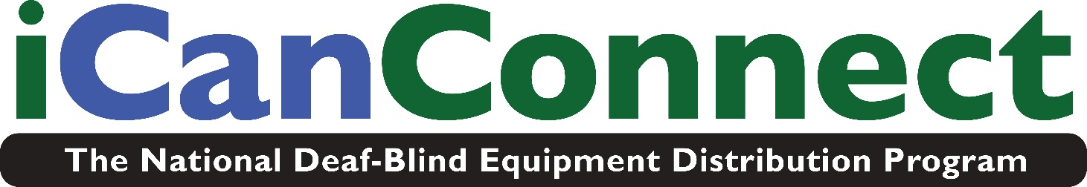

Application Section 1 of 3: Instructions and Guidelines
Overview
The National Deaf-Blind Equipment Distribution Program (NDBEDP) supports local programs that distribute equipment to low-income individuals who are deaf-blind (have combined hearing and vision loss) to enable access to telephone, advanced communications, and information services. This support was mandated by the Twenty-First Century Communications and Video Accessibility Act of 2010 (CVAA) and is provided by the Federal Communications Commission (FCC). For more information about the NDBEDP, please visit http://icanconnect.org or http://www.fcc.gov/ndbedp.

Who is eligible to receive equipment?
Under the CVAA, only low-income individuals who are deaf-blind are eligible to receive equipment provided through the NDBEDP. Applicants must provide verification of their status as low-income and deaf-blind.

Income eligibility
To be eligible, your total family/household income must be below 400% of the Federal Poverty Guidelines, as shown in the following table:

2026 Federal Poverty Guidelines
Number of persons in family/household | 400% for everywhere, except Alaska and Hawaii | 400% for Alaska | 400% for Hawaii
1 | $63,840 | $79,800 | $73,440
2 | $86,560 | $108,200 | $99,560
3 | $109,280 | $136,600 | $125,680
4 | $132,000 | $165,000 | $151,800
5 | $154,720 | $193,400 | $177,920
6 | $177,440 | $221,800 | $204,040
7 | $200,160 | $250,200 | $230,160
8 | $222,880 | $278,600 | $256,280
For each additional person, add | $22,720 | $28,400 | $26,120
Source: U.S. Department of Health and Human Services

For purposes of determining income eligibility for the NDBEDP, the FCC defines “income” and “household” as follows:

“Income” is all income actually received by all members of a household. This includes salary before deductions for taxes, public assistance benefits, social security payments, pensions, unemployment compensation, veteran's benefits, inheritances, alimony, child support payments, worker's compensation benefits, gifts, lottery winnings, and the like. The only exceptions are student financial aid, military housing and cost-of-living allowances, irregular income from occasional small jobs such as baby-sitting or lawn mowing, and the like.
A “household” is any individual or group of individuals who are living together at the same address as one economic unit. A household may include related and unrelated persons. An “economic unit” consists of all adult individuals contributing to and sharing in the income and expenses of a household. An adult is any person eighteen years or older. If an adult has no or minimal income, and lives with someone who provides financial support to him/her, both people shall be considered part of the same household. Children under the age of eighteen living with their parents or guardians are considered to be part of the same household as their parents or guardians.

See Section 2 for the family/household income information that must be provided with this application: either 1) proof of your current participation in a federal low-income program whose income limit is below 400% of the Federal Poverty Guidelines, or 2) proof of household income.

Disability eligibility
For this program, the CVAA requires that the term "deaf-blind" has the same meaning given by the Helen Keller National Center Act. In general, the individual must have a certain vision loss and a hearing loss that, combined, cause extreme difficulty in attaining independence in daily life activities, achieving psychosocial adjustment, or obtaining a vocation (working).

Specifically, the FCC’s NDBEDP rule 64.6203(c) states that an individual who is “deaf-blind” is:

(1) Any individual:
(i) Who has a central visual acuity of 20/200 or less in the better eye with corrective lenses, or a field defect such that the peripheral diameter of visual field subtends an angular distance no greater than 20 degrees, or a progressive visual loss having a prognosis leading to one or both these conditions:
(ii) Who has a chronic hearing impairment so severe that most speech cannot be understood with optimum amplification, or a progressive hearing loss having a prognosis leading to this condition; and
(iii) For whom the combination of impairments described in . . . (i) and (ii) of this section cause extreme difficulty in attaining independence in daily life activities, achieving psychosocial adjustment, or obtaining a vocation.
(2) An individual’s functional abilities with respect to using Telecommunications service, Internet access service, and advanced communications services, including interexchange services and advanced telecommunications and information services in various environments shall be considered when determining whether the individual is deaf-blind under . . . (ii) and (iii) of this section.

(3) The definition in this paragraph (c) also includes any individual who, despite the inability to be measured accurately for hearing and vision loss due to cognitive or behavioral constraints, or both, can be determined through functional and performance assessment to have severe hearing and visual disabilities that cause extreme difficulty in attaining independence in daily life activities, achieving psychosocial adjustment, or obtaining vocational objectives.

Who can attest to a person’s disability eligibility?
A practicing professional who has direct knowledge of the person's vision and hearing loss, such as:

- Audiologist
- Community-based service provider
- Educator
- Hearing professional
- HKNC representative
- Medical/health professional
- School for the deaf and/or blind
- Specialist in Deaf-Blindness
- Speech pathologist
- State equipment/assistive technology program
- Vision professional
- Vocational rehabilitation counsellor
Such professionals may also include, in the attestation, information about the individual’s functional abilities to use telecommunications, Internet access, and advanced communications services in various settings.

See Section 3 for the disability attestation information that must be provided with this application.

Confidentiality policy
iCanConnect is committed to ensuring that your privacy is protected. Information provided on this application form will only be used to determine eligibility for iCanConnect products and services. iCanConnect will not sell, distribute or lease your personal information to third parties unless you give permission, or if the iCanConnect program is required by law to do so. iCanConnect is committed to ensuring that personal information is secure. In order to prevent unauthorized access or disclosure, suitable physical, electronic and managerial procedures are in place to safeguard and secure the information iCanConnect collects.
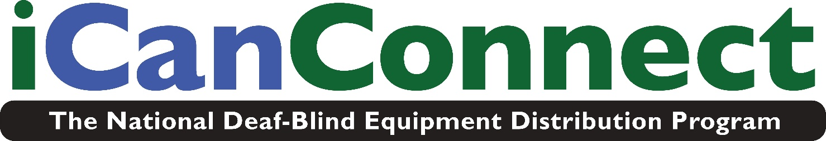

Application Section 2 of 3: Applicant’s Personal Data

(Please fill in all fields)

Name of Applicant: ____________________________

Date of birth: _________________________

Gender: ________________________

(If you are under age 18, your parent or legal guardian must sign the application.)

Street Address:_________________________________

City/State/Zip Code: _____________________________

Primary Phone: _______________Voice __ TTY__ VP__

Alternate Phone: ___________________

E-mail: _____________________________

State in which you are a permanent resident _____________

Have you participated in iCanConnect (the National Deaf-Blind Equipment Distribution Program) before? (check Yes or No) Yes ___ No ___

If yes, what state/states did you participate in iCanConnect? (list all):

________________________________________________

Did you previously receive equipment through iCanConnect in another state?
(check Yes or No) Yes ___ No ___

If yes, what state/states did you receive equipment through iCanConnect? (list all):

__________________________________________________

How many people are living in your household? _____

Language preference (check all that apply):
___ ASL ___ Close Vision ASL/PSE
___ Tactile ASL/PSE ___ English (spoken)
___ No Formal Language ___ Pidgin Signed English
___ Signed English ___ Spanish (spoken)
___ Other __________

Which format do you prefer for written correspondence?
___ Braille ___ E-mail
___ Large Print ___ Standard Print
___ Other ___________

Prefer to be contacted by:
___ E-mail ___ Fax
___ Text Message ___ TTY (dial 711 for Relay)
___ Video Phone ___ Phone (voice)

Alternate Contact (in case of emergency):

_____________________________________________

Relationship with Applicant: _____________________

Street Address: ________________________________

City/State/Zip Code: ____________________________

Primary Phone: _______________________________

E-mail: _____________________________

Feedback/Suggestions (optional):

______________________________________________

How did you hear about this program?

____ iCanConnect.org website
____ Friends
____ Conference or Seminar
____ Family Members
____ Disability advocacy group
____ Interpreter
____ Specialist in Deaf-Blind Services
____ Senior Center
____ Education provider /School
____ Technology vendor
____ Healthcare provider
____ Helen Keller National Center (HKNC) representative
____ Independent Living Center
____ News / Media (television, magazine, radio)
____ Social Media (Facebook, Twitter)
____ State Deaf-Blind Project
____ Vocational Rehabilitation Counselor
____ Other ______________________

Income eligibility
To confirm your income eligibility, please mail or fax documentation that proves one of the following:

- You are currently enrolled in a federal program with an income eligibility requirement that does not exceed 400% of the Federal Poverty Guidelines, such as:
  - Medicaid
  - Supplemental Security Income (SSI)
  - Federal public housing assistance or Section 8
  - Food Stamps or Supplemental Nutrition Assistance Program (SNAP)
  - Veterans and Survivors Pension Benefit; OR

- Proof of all household income (as described in Section 1)

Please mail or fax a copy of last year’s Federal IRS 1040 tax form(s) filed by you and members of your family/household or send other evidence of your total family/household income, such as recent Social Security Administration retirement benefit statement(s) or other pension benefit statement(s).

Applicant attestation (signature required)

I certify that all information provided on this application, including information about my disability and income, is true, complete, and accurate to the best of my knowledge. I authorize program representatives to verify the information provided.

I permit information about me to be shared with my state's current and successor program managers and representatives for the administration of the program and for the delivery of equipment and services to me. I also permit information about me to be reported to the Federal Communications Commission for the administration, operation, and oversight of the program. If I move and apply to any other state iCanConnect program, I also permit all state iCanConnect program(s) I participated in to send my program records to any other state iCanConnect program I apply to.

If I am accepted into the program, I agree to use program services solely for the purposes intended. I understand that I may not sell, give, or lend to another person any equipment provided to me by the program.

If I provide any false records or fail to comply with these or other requirements or conditions of the program, program officials may end services to me immediately. Also, if I violate these or other requirements or conditions of the program on purpose, program officials may take legal action against me.

I certify that I have read, understand, and accept these conditions to participate in iCanConnect (the National Deaf-Blind Equipment Distribution Program).

Print name of applicant or parent/guardian (if applicant is under age 18):

______________________________________________

Signature: _________________________________

Date: _____________________

If this application is completed by someone other than the applicant, please state your name:

______________________________________________

By affixing my name above, I certify that I am signing this application for the applicant and with the applicant’s knowledge and consent.

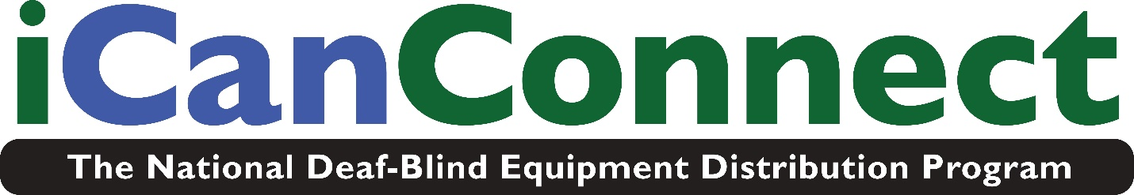

Code of Conduct

In order to maintain a safe and supportive environment for our staff, contractors and customers we ask that you comply with basic safety requirements. While we encourage active participation and communication, we do ask that this be done in a civil manner even when there are disagreements or uncomfortable discussions taking place. Should you have concerns about how staff is relating to you that you are unable to work out with staff, you are encouraged to talk with the iCanConnect Manager.
Listed below are behaviors that are unacceptable for anyone in contact with our staff either in the office or in the community. These same expectations apply to our staff as well. Violation of this code of conduct may result in immediate termination of services from the NDBEDP program. In addition, law enforcement authorities may be contacted, and appropriate legal action taken should a violation occur.

NO WEAPONS
NO THREATS (VERBAL, WRITTEN OR PHYSICAL)
NO AGGRESSIVE BEHAVIOR (VERBAL, WRITTEN OR PHYSICAL)
NO HARASSMENT (VERBAL, WRITTEN OR PHYSICAL)
NO PROPERTY DAMAGE

Your signature is required in order to continue with iCanConnect services

I certify that I have read, understand, and accept these conditions to participate in iCanConnect (the National Deaf-Blind Equipment Distribution Program).
Print name of applicant or parent/guardian (if applicant is under age 18):

______________________________________________________________________

Signature: ________________________________________________________
Date: _____________________
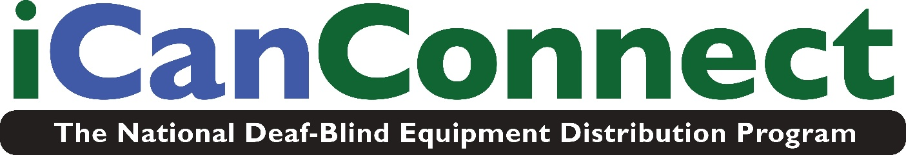

Application Section 3 of 3: Disability Verification

This disability verification section is to be completed by a practicing professional who has direct knowledge of the applicant's vision and hearing loss.

Please complete the following fields, and sign and date at the bottom.

Name and Address of Deaf-Blind Individual:

Name of Applicant: _____________________________

Address: _______________ City/State/Zip: __________

Attester Information:

Name of Attester: ____________________Title: _____

Agency/Employer: _____________________________

E-mail: _______________________ Phone: ________

Street Address: ________________________________

City/State/Zip: _______________________

For this program, the CVAA requires that the term "deaf-blind" has the same meaning given by the Helen Keller National Center Act. In general, the individual must have a certain vision loss and a hearing loss that, combined, cause extreme difficulty in attaining independence in daily life activities, achieving psychosocial adjustment, or obtaining a vocation (working).

Specifically, the FCC’s NDBEDP rule 64.6203(c) states that an individual who is “deaf-blind” is:

(1) Any individual:
(i) Who has a central visual acuity of 20/200 or less in the better eye with corrective lenses, or a field defect such that the peripheral diameter of visual field subtends an angular distance no greater than 20 degrees, or a progressive visual loss having a prognosis leading to one or both these conditions;
(ii) Who has a chronic hearing impairment so severe that most speech cannot be understood with optimum amplification, or a progressive hearing loss having a prognosis leading to this condition; and
(iii) For whom the combination of impairments described in . . . (i) and (ii) of this section cause extreme difficulty in attaining independence in daily life activities, achieving psychosocial adjustment, or obtaining a vocation.

(2) An applicant's functional abilities with respect to Telecommunications service, Internet access service, and advanced communications services, including interexchange services and advanced telecommunications and information services in various environments shall be considered when determining whether the individual is deaf-blind under . . . (ii) and (iii) of this section.

(3) The definition in this paragraph (c) also includes any individual who, despite the inability to be measured accurately for hearing and vision loss due to cognitive or behavioral constraints, or both, can be determined through functional and performance assessment to have severe hearing and visual disabilities that cause extreme difficulty in attaining independence in daily life activities, achieving psychosocial adjustment, or obtaining vocational objectives.

I certify under penalty of perjury that, to the best of my knowledge, this individual is deaf-blind as defined by the FCC as above (and as previously referenced in Section 1).

My attestation is based on the following:

(Please state how you are familiar with each of the applicant's hearing and vision loss, AND the applicant’s combination of hearing and vision loss, as defined in the FCC’s NDBEDP rules listed directly above):

Vision loss: ______________________________________________________

______________________________________________________________________

Hearing loss: ____________________________________________________

Describe how the Combination of hearing and vision loss affects this person in daily life (Please refer to the definition of deaf-blind in this section of the application):

______________________________________________________________________

Attester Signature:

________________________________ Date _________

Mail, e-mail, or fax completed application
(Sections 2 and 3) to:

Chad Metcalf
Helen Keller National Center
PO Box 4269
Crestline, CA 92325
E-mail: cmetcalf@helenkeller.org
• Video phone: 951-208-6548
• Fax 617-972-7668

If scanned documents are submitted, please use PDF format.
(This document is available upon request in hard copy print, braille, and electronic text.)

Privacy Statement

The Federal Communications Commission (FCC) collects personal information about individuals through the National Deaf-Blind Equipment Distribution Program (NDBEDP), a program also known as iCanConnect. The FCC will use this information to administer and manage the NDBEDP.

Personal information is provided voluntarily by individuals who request equipment (NDBEDP applicants) and individuals who attest to the disability of NDBEDP applicants. This information is needed to determine whether an applicant is eligible to participate in the NDBEDP. In addition, personal information is provided voluntarily by individuals who file NDBEDP-related complaints with the FCC on behalf of themselves or others. When this information is not provided, it may be impossible to resolve the complaints. Finally, each state’s NDBEDP-certified equipment distribution program must submit to the FCC certain personal information that it obtained through its NDBEDP activities. This information is required to maintain each state’s certification to participate in this program.

The FCC is authorized to collect the personal information that is requested through the NDBEDP under sections 1, 4, and 719 of the Communications Act of 1934, as amended; 47 U.S.C. 151, 154, and 620.

The FCC may disclose the information collected through the NDBEDP as permitted under the Privacy Act and as described in the FCC’s Privacy Act System of Records Notice at 77 FR 2721 (Jan. 19, 2012), FCC/CGB-3, “National Deaf-Blind Equipment Distribution Program (NDBEDP),”

https://www.fcc.gov/omd/privacyact/documents/records/FCC-CGB-3.pdf.

This statement is required by the Privacy Act of 1974, Public Law 93-579, 5 U.S.C. 552a(e)(3).

