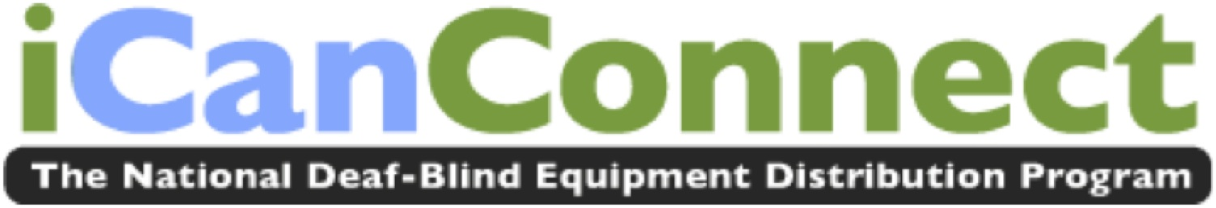

SC Couple with Hearing and Vision Loss Discover New Opportunities to Communicate with iCanConnect

As a girl growing up with profound hearing loss, Ami Patrick of Taylor, South Carolina taught herself sign language. It came in handy years later when she attended a camp for deaf adults and met the man who would soon become her husband.

“I remember the first time I told him what my name was,” recalls Ami Patrick, who is now 49-years-old. “I was shy.”

Samuel Patrick tells the story of that first meeting differently: “Ami was never shy.”

Nearly 20 years after exchanging wedding vows, the Patrick’s have few problems communicating with one another, but communicating with the rest of the world has always been a challenge.

Each is deaf with only limited vision. Until recently, they struggled with the basics like reading the labels on medicine bottles and sending emails, but not anymore. The Patricks are among a rapidly growing number of people with combined vision and hearing loss who are benefiting from the National Deaf-Blind Equipment Distribution Program, which is promoted as iCanConnect. It offers qualified consumers with significant hearing and vision loss communications technology at no cost.

The Patricks received a MacBook Pro laptop and an iPad mini through the program. Each offers a high resolution screen and easily adjustable font size. Now, with their new communications tools, it’s simple to send emails to friends, join online conversations and access information on the Internet. Samuel is using his newfound access to technology to search for a job.

“I would like to find something in computer repairs or some kind of tech job,” he says.

Ami also received a hands-free magnifier through iCanConnect, which enables her to read the fine print on the prescription medication she needs to manage her Multiple Sclerosis. And, she is now able to pursue her favorite pastimes.

“Ten years ago I had to give up sewing because I couldn’t see anything with double-vision,” explains Ami. “Now I am able to sew again. I’ve also been doing some painting, lots of different art and crafts projects.”
“This program opens up entirely new horizons,” explains Sharon Giovinazzo, who is a trainer with iCanConnect and helped teach the Patrick’s how to use their new technology.
“Samuel and Ami had their own little world, now they are able to reach out. They are doing video chats and they are on Facebook. They’re just well connected.”

“We feel extremely blessed, can’t emphasize that enough,” says Ami. “We’re really thankful for all this equipment and the changes it has made in our lives.”

Now in its second year, iCanConnect, offers a wide array of options - from iPads, to phone amplifiers to screen-reading software – all designed to help people with significant hearing and vision loss stay connected to family, friends and community. Along with the equipment, iCanConnect provides individualized assessment and training at no charge to qualified consumers who meet income guidelines. The program is available in all 50 states, the District of Columbia, Puerto Rico and the U.S. Virgin Islands.

Learn more at www.iCanConnect.org. The website accommodates users with low vision, people who use screen readers and features video that is both audio-described and closed captioned. Information about iCanConnect is also available by calling 1-800-825-4595 | TTY: 1-888-320-2656.

###

